
May 13, 2025
MONO COUNTY BOARD OF SUPERVISORS (Kreitz, Duggan, McFarland, Peters, Salcido)
MONO COUNTY ADMINISTRATION (Chief Admin Officer Moberly, Clerk Barnard, Asst Clerk Ybarra, Sheriff Braun, County Counsel Beck, District Attorney Anderson)
MONO COUNTY PUBLIC HEALTH (Director Wheeler)
SUBJECT: BOARD OF SUPERVISORS MEETING 5/13/25 OPPORTUNITY FOR PUBLIC TO ADDRESS THE BOARD
Dear Supervisors, Administration and Public Health Department,
My name is Julie Threet and I am a former public healthcare worker from Butte County who traveled here today to ask that you stop administration of the deadly COVID vaccine in your County. I am traveling in person from County to County with another public health whistleblower, Ronald F Owens Jr. to ask those responsible to stop administration of this deadly poison and consider investigating those responsible for spreading misinformation about the safety of this shot in your County.
https://hhsa.cosb.us/immunizations/
I have spoken before 22 counties a total of 67 times traveling over 8,400 miles: Butte, Santa Clara, Shasta, Glenn, Colusa, Tehama, Marin, Nevada, Plumas, Sacramento, Lake, Yuba, Sutter, Monterey, Tuolumne, San Francisco, Calaveras, Mariposa, Merced, Ventura and San Benito. I have given testimony to Boards of Supervisors, City Council, School Board, CA Department of Pharmacy and a New California State Town Hall.
FOR THE RECORD, I am vaccine injured myself by the COVID-19 vaccine and have a VAERS Report filed:
https://medalerts.org/vaersdb/findfield.php?IDNUMBER=2302355
I suffer from microangiopathy, tinnitus, and have had two detached retinas (requiring five emergency eye surgeries). I also have a heart condition that has yet to be properly diagnosed but has limited my ability to enjoy my life with my grandchildren.
AGAIN, I WORKED FOR BUTTE COUNTY PUBLIC HEALTH IN 2021 HELPING ADMINISTER THE VACCINES IN CHICO. I AM A WHISTLEBLOWER HAVING WITNESSED INJURIES IN THE CHAIR. With the extent of my injuries, and the injuries I witnessed all around me, I started researching everything to find out who to hold accountable, what we needed to do to help people heal, and to make sure NOT ONE SINGLE BABY, SENIOR CITIZEN OR MILITARY VETERAN GOES BLIND LIKE I DID FROM THIS POISON.
I am a member of Medical Doctors for COVID Ethics International and now LEAD INVESTIGATOR FOR VAERSAware.com AN ORGANIZATION THAT PROVIDES CRITICAL DATA BY BATCH NUMBER. Have your PUBLIC HEALTH team check on the relative lot toxicity at this site and notify your citizens accordingly. Notify those who may have received the recalled Moderna lot #041L20A. Your Health Department has this information.
https://www.vaersaware.com/
Here’s the information from your website. PLEASE REMOVE THIS MISINFORMATION. They are NOT “safe”. They do NOT stop transmission or prevent disease.
https://monohealth.com/public-health/page/immunizations
https://monohealth.com/public-health/page/coronavirus-covid-19
1. Vaccines Have Saved Lives for Over 100 Years—But Serious Disease Is Still a Threat
2. Vaccines Are the Best Way to Protect Yourself and Your Loved Ones from Preventable Disease
3. Vaccines Can Prevent Serious Illness
4. The Vaccines You Receive Are Safe
5. Vaccines May Be Required
Item #2: I RESPECTFULLY REQUEST INFORMATION ON THE CHRONIC ILLNESS RATE OF CHILDREN IN YOUR COUNTY, AND/OR THE NUMBER OF CHILDREN IN YOUR PUBLIC SCHOOL SYSTEM ON AN INDIVIDUALIZED EDUCATION DISABILITY PLAN (IEP). I venture to guess your children, over time, are experiencing MORE disabilities of all kinds that years past.
Item #3: I RESPECTFULLY REQUEST THAT YOU START INCLUDING ALL TREATMENT OPTIONS BEYOND VACCINATIONS – e.g. Include Ivermectin, Vitamin D, etc.
Item #4: I RESPECTFULLY REQUEST THAT YOU ARE FULLY TRANSPARENT AND EDUCATE YOUR CITIZENS ON THE REAL RISKS THAT COME WITH VACCINATIONS. POST THE VAERS DATA ON YOUR WEBSITE FOR ALL VACCINES – INCLUDING FLU, MEASLES, PERTUSSIS.
DO YOUR OWN RESEARCH!
I am not asking you to just believe me, but to go do your own research, and SET UP TIME ON A FUTURE AGENDA FOR US TO BRING SUBJECT MATTER EXPERTS (listed on last page) LIKE FRANKLIN COUNTY WASHINGTON DID, AND THE ENTIRE STATE OF IDAHO DID, TO GIVE YOU AS RESPONSIBLE ELECTEDS ALL OF THE “SCIENCE”:
- REACT19: The current leading lobbyist and subject matter resource for the COVID19 vaccine injured and bereaved. Their website contains every existing credible science research paper, legal claims, and health detox resources. There are now over 3,000 papers refuting the “safe & effective” lie.
https://react19.org/
- FORMER FEDS FREEDOM FOUNDATION: Another professional group of legal professionals fighting COVID crimes including the deadly hospital protocol using Remdesivir. There are thousands of stories of victims murdered in the hospital (including Enloe). There are support groups available weekly for the injured.
https://formerfedsgroup.org/
- AMERICANS FOR HEALTH FREEDOM: A current platform led by Dr. Mary Talley-Bowden who has solicited the names of any candidate and/or elected official from across the Country who will pledge to commit to doing everything to stop the shots and not take any campaign funds from big pharma. SIGN THE PLEDGE!
https://www.americansforhealthfreedom.org/
- MILITARY ACCOUNTABILITY: A petition signed by 37,870 veterans who oppose the COVID19 vaccine.
https://militaryaccountability.net/
- FRANKLIN COUNTY COMMISSIONERS, IDAHO SOUTHEAST HEALTH DISTRICT AND IDAHO STATE LEGISLATURE: Video of their use of subject matter experts to back up claims from citizens:
https://rumble.com/v6e7oe1-franklin-county-wa-commissioners-121824-presentation-on-covid-vaccine-dange.html
https://rumble.com/v6ro3bt-idahos-health-freedom-act-becomes-law.html?s=35
https://www.youtube.com/live/NJJexxaSf3M
OTHER ACTIONS:
Please notify the members of your community who have been injected with at least one shot of the current vaccine and survey their health status. Help them file a VAERS Report if they experienced COVID or other health issues post-vaccine. Check on the first responders and healthcare workers who were MANDATED to receive a vaccine at the beginning of this campaign in December 2020 and survey their health status.
Pull all information related to the COVID vaccines off your website. Let pharmacies take the liability.
I AM AVAILABLE TO MEET WITH YOUR HEALTH AGENCY STAFF and I will train any team member on running data from VAERS as I have for you today using the National Vaccine Information Center’s Search Engine:
https://www.medalerts.org/vaersdb/index.php
Here are THE CURRENT VAERS NUMBERS FOR THE COVID VACCINE! I can train your staff to run these and more from this search engine. These are official VAERS numbers AS OF 4/25/25 that you are obligated to post on your website for true informed consent.
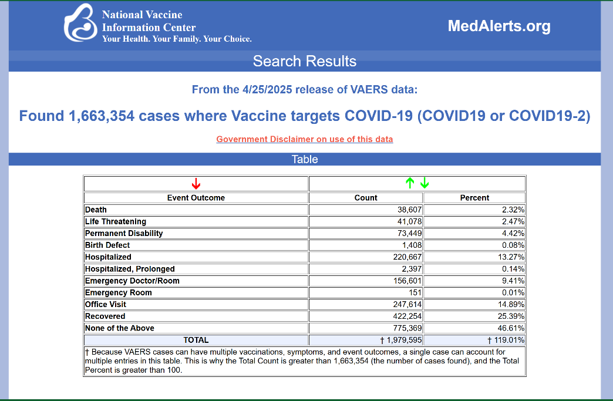
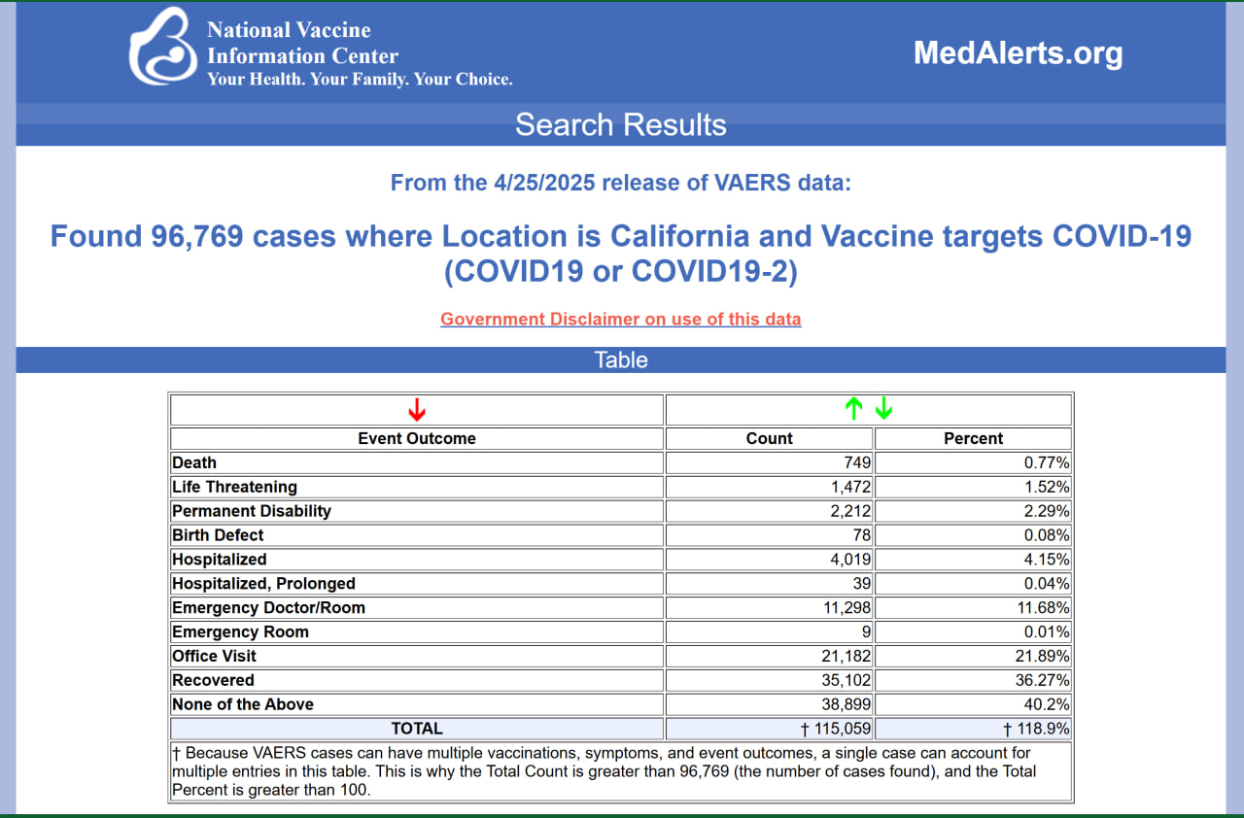
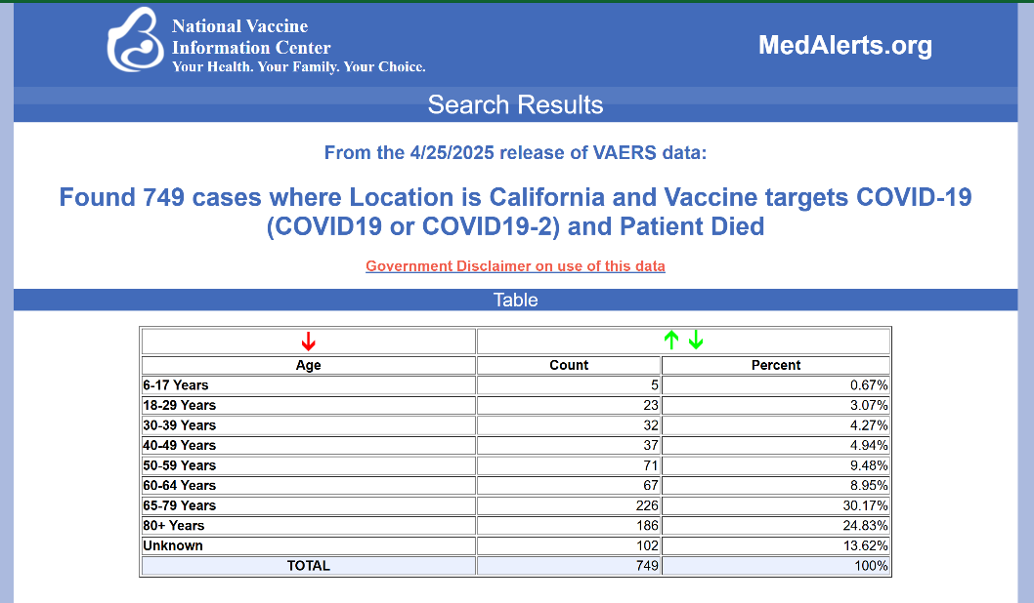

CONCLUSION:
I will not leave this planet until there is accountability and full stop to this manmade disaster. And to support all victims of this toxic product.
THE LACK OF RESPONSE AND RESPECT FOR US INJURED IS INFURIATING AND UNACCEPTABLE. DO NOT CONTINUE WITH THIS PRODUCT IN YOUR COUNTY!
I HOPE YOU WILL BE ONE OF THE FIRST BRAVE PATRIOTIC COUNTIES IN CALIFORNIA TO DO THE RIGHT THING AND STAND UP TO GOVERNOR NEWSOM AND WORK HARD TO ENSURE FORMER HHS SECRETARY XAVIER BECERRA DOES NOT REPLACE NEWSOM AND CONTINUE TO JEOPARDIZE OUR MEDICAL FREEDOM.
THANK YOU FOR YOUR ATTENTION TO THIS CRITICAL ISSUE. I am just a mom, grandmother and concerned American.
Sincerely,

Whistleblower fighting Public Health/Medical Establishment Corruption
COVID Victim Advocate fighting for Justice
Phone: 510-358-7520
Email: julie4butte5@gmail.com
Twitter/X: https://x.com/julie4butte5 & Member “Stop the Shots Community”
Rumble Channel:
https://rumble.com/user/PrayingHawk144
Lead Investigator for VAERSAware.com: https://www.vaersaware.com/my-team
Certified by National Vaccine Information Center in VAERS search engine:
https://medalerts.org/index.php
Member Medical Freedom Groups: React19.org; Covid Humanity Betrayal Project (CHBMP.org); Medical Doctors for COVID Ethics International
Political Activist: Leader in “Butte County for Kennedy Campaign” in 2024; GOP Candidate for Butte County Supervisor for District 5 in 2024; first in California to sign politicians pledge to stop the COVID vaccine and refuse donations from pharma: https://www.americansforhealthfreedom.org/
Retired Executive in Silicon Valley: 25 yr career in Human Resources Operations; from Analyst to Managing Vice President; Compensation, Benefits, Stock, Systems, Mergers; employed by Lucent Technology, International Network Services, NetApp, Coherent, Octel, Varian
Former Healthcare Worker at Enloe Health in Chico: Patient Ambassador and Volunteer Services Board Member; forced to resign when booster mandated
Former Nurse Helper for Butte County Public Health: Worked Butte County Vaccination Clinics (COVID/Flu) from Jan, 2021 to Sept, 2021; distributed syringes to nurse volunteers; worked draw room; completed vaccination cards
Education: BS Business Management, University of Wyoming;
Medical Terminology & Billing courses, Butte Community College
Currently disabled by two shots of COVID-19 Moderna vaccine: Microangiopathy, tinnitus, three detached retinas, five eye surgeries, current undiagnosed heart issue; filed VAERS Report ID 2302355:
https://medalerts.org/vaersdb/findfield.php?IDNUMBER=2302355
Mom killed by four shots of COVID-19 Moderna vaccine (sudden cardiac event); filed VAERS Report ID 2431153 and CICP Claim with HRSA CICP2302230005; Video filing VAERS Report:
https://www.bitchute.com/video/aQts1KLE5VZJ/
PUBLISHED VAERS RESEARCH:
Co-author on this research study proving this COVID vaccine is dangerous for pregnant women and causing fetal demise, miscarriages and infertility.
https://www.preprints.org/manuscript/202406.2062/v1
https://www.preprints.org/manuscript/202407.0069/v1
INTERVIEWS (MANY OTHERS AVAILABLE):
- AGENDA 21 RADIO WITH PAUL PRESTON OF NEW CALIFORNIA STATE (1/23/25):
https://rumble.com/v6coz3g-threet-and-owens-agenda-21-radio-with-paul-preston-12325.html
- THE AMERICAN GRANDDAUGHTER PODCAST (4/23/25):
https://rumble.com/v6sheir-the-american-granddaughter-julie-threet-ronald-owens-and-jeremiah-hosea.html
- AMERICA OUTLOUD WITH DR MARY TALLEY BOWDEN (2/6/25):
https://www.americaoutloud.news/big-fights-in-bite-sized-pieces/
- CHILDREN’S HEALTH DEFENSE LIVE “FOLLOW THE SCIENCE SHOW” (10/9/24)
https://live.childrenshealthdefense.org/chd-tv/shows/good-morning-chd/follow-the-science/?utm_source=simpletexting&utm_medium=sms&utm_campaign=chdtvtxt&utm_id=20241009
- THE BASSLINE WITH JEREMIAH HOSEA (9/13/24):
https://thebassline.podbean.com/e/the-baseline-episode-57/
- PATRIOT’S PRAYER (1/13/24):
https://rumble.com/v46sz5u-episode-120-interview-with-julie-threet.html
- REINETTE SENUM FOGHORN EXPRESS (9/2/22):
https://reinettesenumsfoghornexpress.substack.com/p/health-care-worker-vows-justice-for#playnn

DOCTORS/RESEARCHERS/POLITICIANS AVAILABLE TO YOU AS MY CONTACTS/REFERENCES:
Dr. James Thorp: Board-certified OB/GYN in Florida with 45 years of OB experience specializing in high-risk Maternal & Fetal Medicine; author of “Sacrifice: How the Deadliest Vaccine in History Targeted the Most Vulnerable”, “The COVID-19 Vaccines & Beyond – What the Medical Industrial Complex is NOT Telling Us”
Dr. Kimberly Biss: Board-certified OB/GYN in Florida; served on Board of Trustees, Physician’s Technology Council and Chairman of the OB/GYN Department at Bayfront Health Hospital; Dr Biss was invited to Washington DC in November 2023 to present her practice data to a congressional panel
Dr. Renata (Reni) Moon, MD, FCP: Board-certified in General Pediatrics and Pediatric Hospital Medicine with 25 years in Washington; Clinical Associate Professor of Medicine; recently joined FLCCC Alliance as Senior Fellow in Pediatrics; after testifying to Senator Ron Johnson’s COVID-19 vaccine roundtable
Albert Benavidez: Creator of VAERSAware.com; Chico State Graduate; Medical biller located in Silicon Valley; author of Welcome the Eagle Substack reporting on variances and issues with CDC’s VAERS System
Dr. Mary Talley Bowden, MD: Dr. Mary Talley Bowden is an otolaryngologist, sleep medicine and upper airway specialist in Houston, Texas. An outspoken advocate for medical freedom, Dr. Bowden successfully kept over 6,000 COVID patients out of the hospital during the pandemic. Dr. Bowden started a nonprofit, Americans for Health Freedom, to track politicians pledging to pull COVID vaccines off the market
Alix Mayer, MBA: Chairman & Co-Founder Free Now Foundation a medical freedom non-profit advocating for parental rights over healthcare decisions; Former President Children’s Health Defense; former executive at Apple running worldwide research group; Hep B Vaccine Injury Survivor
Stanford Graham: Attorney fighting COVID crimes from mask mandates to criminal charges against Dr. Fauci and Dr Ralph Baric; Executive Director of Senacor International and Producer of Cardio Miracle.
Dr. Judy Mikovitz, PhD: Former biochemistry research scientist fighting for truth in research. 40 yr quest to understand the causes, prevention and treatment of chronic diseases; co-author of numerous papers in immunology, epigenetics and HIV/AID’s drug development; NY Times best-selling author of several books
Dr. Henry Ealy, ND: Founder & Executive Community Director Energetic Health Institute a school teaching about the power of Natural Medicine; supports people recovering from vaccine injuries; Executive Producer “Healing for the AGES”; leading COVID Grand Jury Initiative
Dr. Holly Groh: Ophthalmologist in Louisiana and public health activist; led a successful effort to pass state legislation that created medical oversight for students using digital devices; researching the adverse effects of the COVID19 vaccine on eyes.
Dr. Ben Marble: Emergency Room physician in Florida and founder of myfreedoctor.com a free telehealth service committed to providing ivermectin to all patients.
Laura Demaray, RN, BA, CWON: “Restoring Hope for the Injured” podcast; advocate for civil liberties and recent organizer of presentations before Idaho Southwest Health District that stopped funding COVID19 vaccines; organizer of agenda item presentation before Franklin County Commissioners in Washington

