
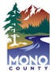
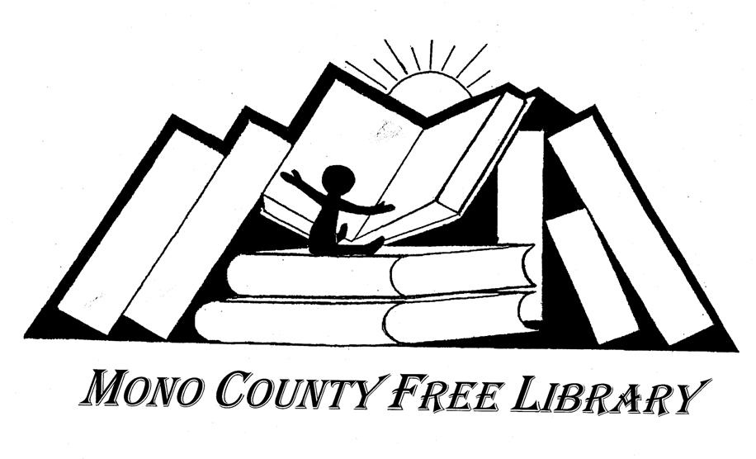

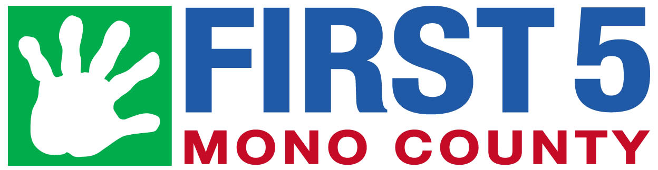
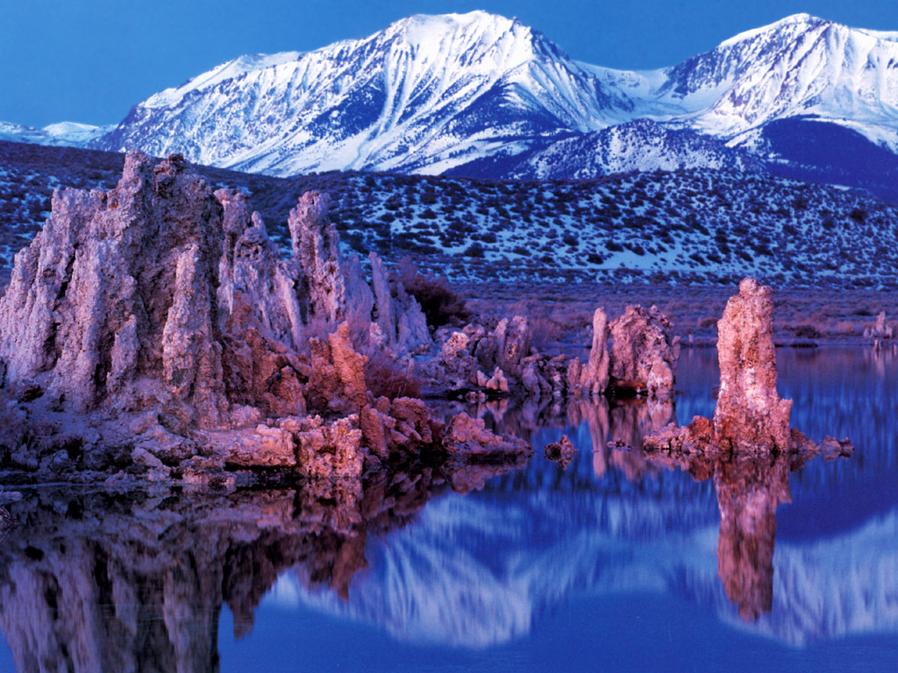
Mono County Child Abuse Prevention Council (CAPC)
www.mono.ca.gov/capc
Updated July 1, 2020 Revisado 1 de July, 2020
2020-2021

Mono County Community Resource Guide

Guía de Recursos Comunitarios de Mono County
Strengthening Families with the 5 Protective Factors

- Resilience
Resilience is the ability to bounce back from all types of challenges. It means finding ways to solve problems, building and sustaining trusting relationships, taking care of you, and knowing it is OK to seek help when necessary.
- Social Connections
Everyone needs to feel cared for and connected. Friends, family members, neighbors and community members provide emotional support, help solve problems, offer insights and give concrete assistance.
- Knowledge of Parenting & Child Development
Being a good parent is part natural and part learned. Parents, who understand child development, are responsive to their child’s needs and practice positive parenting strategies will feel more engaged and empowered. Kids thrive in an environment that fosters secure attachments and healthy development.
- Concrete Support in Times of Need
Everyone faces challenging times. It is important to know where to access support services and that it is OK to ask for help.
- Teach Children Social and Emotional Competence
Be a good role model. Teach children to communicate clearly and express their feelings effectively. Help them learn how to be a good friend. A child/youth who is able to interact positively with others, self-regulate their behavior and effectively communicate their feelings will be able to build and sustain healthy relationships throughout their lifetime.

For More Information on the
5 Protective Factors visit
The Center of the Study of Social Policy
http://www.cssp.org/reform/strengtheningfamilies

“Like” or “Friend” us at
Mono Strengthening Families/Facebook

Fortaleciendo Familias con los
5 Factores de Protección

- Resiliencia
Resiliencia es la habilidad de recuperarse de todo tipo de desafíos. Significa encontrar maneras de resolver problemas, desarrollar y mantener relaciones de confianza, cuidar de si mismo, y saber que está bien buscar ayuda cuando sea necesario.
- Conexiones sociales
Todo el mundo necesita sentirse querido y conectado. Amigos, miembros de la familia, vecinos y miembros de la comunidad proveen apoyo emocional, ayudan a resolver problemas, ofrecen entendimiento y dan asistencia concreta.
- Conocimiento de la crianza del niño y del desarrollo del niño
Ser un buen padre es una habilidad en parte natural y en parte aprendida. Aquellos padres que entienden los principios del desarrollo del niño, responden a las necesidades del niño y practican estrategias de crianza positivas se sentirán más comprometidos y fortalecidos. Los niños progresan en un ambiente que fomenta apego seguro y desarrollo saludable.
- Apoyo concreto en momentos de necesidad
Todo el mundo enfrenta momentos difíciles. Es importante saber dónde encontrar servicios de apoyo y que está bien pedir ayuda.
- Enseñe competencia social y emocional a los niños
Sea un buen ejemplo. Enseñe a los niños a comunicarse claramente y a expresar efectivamente sus sentimientos. Ayúdelos a aprender ser un buen amigo. Un niño quien puede interactuar positivamente con otros, auto-regular su comportamiento y comunicar efectivamente sus sentimientos podrá desarrollar y mantener relaciones saludables a través de su vida.

Para más información acerca de los 5 Factores de Protección visite el Centro de Estudios sobre Política Social

http://www.cssp.org/reform/strengtheningfamilies

“Like” or “Friend” us at
Mono Strengthening Families/Facebook

EMERGENCY SERVICES/SERVICIOS DE EMERGENCIA
Fire, Ambulance, Sheriff’s, California Highway Patrol 911
Mammoth Hospital–Emergency Department 760-934-3311
Mono County Sheriff’s Dispatch 760-932-7549
LAW ENFORCEMENT/ORDEN PÚBLICO
California Highway Patrol 760-932-7995
Mammoth Lake Police Department 760-965-3700
Mono County Animal Control 760-932-5630
Mono County Probation, Bridgeport 760-932-5570
Mono County Probation, Mammoth Lakes 760-932-1730
Mono County Sheriff’s Department 760-932-7549
FIRE DEPARTMENTS/DEPARTAMENTO DE BOMBEROS
Antelope Valley 530-495-2900
Benton 760-933-2252
Bridgeport 760-932-7353
June Lake 760-648-7390
Lee Vining 760-647-6400
Long Valley 760-935-4545
Mammoth Lakes 760-934-2300
24-HOUR HOTLINES/TELÉFONOS DE EMERGENCIAS
California Youth Crisis Line 800-843-5200
Child Abuse Hotline 800-422-4453
Child Abuse – To Report Localy 800-340-5411
Mono County Behavioral Health Access Line 800-687-1101
National Domestic Violence Hotline 800-799-7233
National Drug & Alcohol Treatment 800-622-2255
National Parent Support Line 855-427-2736
National Sexual Assault Hotline 800-656-4673
Suicide Prevention Lifeline 800-273-8255
Wild Iris Crisis Line 877-873-7384
HOSPITALS/HEALTH CLINICS
HOSPITALES/CLINICAS DE SALUD
Mammoth Hospital & Clinics 760-934-3311
Mono County Public Health, Bridgeport 760-932-5580
Mono County Public Health, Mammoth 760-924-1830
Toiyabe Indian Health Project 530-495-2100
HEALTH INSURANCE ASSISTANCE
ASISTENCIA CON SEGURO DE SALUD
Covered California Enroll Online http://www.coveredca.com
Mono County Department of Social Services 760-924-1770
SUBSTANCE ABUSE PREVENTION & TREATMENT
PREVENCION Y TRATAMIENTO PARA ABUSO DE SUBSTANCIAS
Alcoholics Anonymous, Alanon & Alateen 800-851-1304
California Smokers Helpline 800-662-8887
Mono County Behavioral Health 760-924-1740
COUNSELING/SERVICIOS DE TERAPÍA Y ORIENTACIÓN
Mono County Behavioral Health 760-924-1740
North Star Counseling Center 760-924-7926
Wild Iris 760-934-2491
FINANCIAL, FOOD &/or CLOTHING
FINANCIAMIENTO, ALIMENTACION y/o ROPA
Antelope Valley Senior Center, Walker 530-495-2323
IMACA 760-934-3343
Mono County Department of Social Services 760-924-1770
Salvation Army Food Pantry 220 Sierra Manor 760-872-2124
Wild Iris 760-934-2491
SHINE 760-648-3075
HOUSING &/or ENERGY ASSISTANCE
ASISTENCIA de VIVIENDA y/o ENERGIA
IMACA 760-934-3343
Mammoth Lakes Housing 760-934-4740
Mono County Department of Social Services 760-924-1770
Wild Iris 760-934-2491
SHINE 760-648-3075

DEVELOPMENTAL SCREENINGS (AGES 0-3 years)/
REVISIÓN DE DESARROLLO (Edades 0-3 años)
First 5 Mono 760-924-7626
Great Steps Ahead 760-872-2270
Kern Regional Center 760-873-7411
MCOE/Early Start 760-934-0031
Sierra Park Pediatric Clinic 760-924-4000
SPECIAL EDUCATION (AGES 3-21 years)/
EDUCACIÓN ESPECIAL (Edades 3-21 años)
MCOE/Pre-K (Ages 3-5) 760-934-0031
Contact School of Attendance (Ages 5-21) -SCHOOLS/ESCUELAS
DISABILITY ASSISTANCE/ASISTENCIA POR DISCAPACIDAD
Community Services Solutions 530-495-2700
Disabled Sports of the Eastern Sierra 760-934-0791
Disability Rights – Advocacy 800-776-5746
Mono County Department of Social Services 760-924-1770
ELDERLY ASSISTANCE &/or SENIOR PROGRAMS/ ASISTENCIA A LA TERCERA EDAD Y/o PROGRAMAS PARA ANCIANOS
Antelope Valley Senior Center 530-495-2323
Community Services Solutions 530-495-2700
Eastern Sierra Area Agency on Aging 877-462-2298
Mono County Department of Social Services 760-924-1770
NATIVE AMERICAN TRIBES/TRIBUS NATIVO AMERICANAS
Bridgeport Indian Colony 760-932-7083
Mono Lake Kutzadika 760-605-6263
Utu Utu Gwaitu Paiute Tribe Benton 760-933-2321
ADDITIONAL NATIVE AMERICAN RESOURCES/
RECURSOS NATIVO AMERICANOS ADICIONALES
Bishop Paiute Tribe 760-873-4477
Owens Valley Career Development Center
Benton Tribal TANF 760-933-2426
Coleville Tribal TANF 530-495-1000
Toiyabe Indian Health Project 760-873-8461
LEGAL SERVICES/SERVICIOS LEGALES
Mono County Child Support Services 866-901-3212
Mono County District Attorney 760-932-5550
Mono County Probation, Bridgeport 760-932- 5570
Mono County Probation, Mammoth Lakes 760-932-1730
Mono County Recorder 760-932-5530
Mono County Superior Court 760-924-5444
Self-help & Family Law Assistance 760-258-7372
TRANSPORTATION/TRANSPORTE
California Road Conditions 800-427-7623
Dial-a-Ride (Mammoth Lakes Only) 760-924-3184
Eastern Sierra Transit 760-872-1901
RECREATION/RECREACIÓN
Mammoth Lakes Welcome Center 760-924-5500
June Mountain Ski Area 760-648-7733
Mammoth Mountain Ski Area 760-934-2571
Town of Mammoth Lakes, Recreation 760-965-3690
VETERAN SERVICES/SERVICIOS PARA VETERANOS
County of Inyo-Mono Veteran Services 760-873-7850
WELLNESS PROGRAMS/PROGRAMAS DE SALUD
Mammoth Hospital 760-934-3311
Mono County Behavioral Health 760-924-1740
Toiyabe Indian Health Community Wellness 760-873-8851
COUNTY & TOWN OF MAMMOTH LAKES GOVERNMENT/ GOBIERNO DEL CONDADO Y PUEBLO DE MAMMOTH LAKES
Mammoth Lakes Town Council/Clerk 760-965-3600
Mono County Board of Supervisors/Clerk 760-932-5530
ADDITIONAL COUNTY & TOWN OF MAMMOTH LAKES BOARDS & COUNCILS/JUNTAS Y CONSEJOS ADICIONALES DEL CONDADO Y PUEBLO DE MAMMOTH LAKES
http://www.ci.mammoth-lakes.ca.us
http://www.mono.ca.gov/boards

NEW PARENT SUPPORTS
APOYO PARA PADRES PRIMERIZOS
First 5 Mono 760-924-7626
Mono County Child Care Council 760-934-3343
Mono County Public Health, Bridgeport 760-932-5580
Mono County Public Health, Mammoth 760-924-1830
Mono County Resource & Referral 760-934-3343
Sierra Park Pediatric Clinic 760-924-4000
Women, Infant and Children (WIC) 760-924-4610
PARENT EDUCATIÓN/EDUCACION PARA PADRES
Car Seat Checks
CHP, Bridgeport 760-932-7995
Mammoth Lakes Police Department 760-965-3700
First 5 Mono 760-924-7626
MCOE/Adult Education 760-934-0031
EARLY CHILDHOOD RESOURCES
RECURSOS PARA LA NIÑEZ TEMPRANA
First 5 Mono 760-924-7626
Mono County Child Care Council 760-934-0031
Mono County Libraries & Raising-a-Reader 760-934-8670
Mono County Public Health, Bridgeport 760-932-5580
Mono County Public Health, Mammoth 760-924-1830
Mono County Resource & Referral (IMACA CCCC) 760-934-3343
Sierra Park Pediatric Clinic 760-924-4000
Women, Infant and Children (WIC) 760-924-4610
CHILD CARE CENTERS/PRESCHOOLS
CENTROS PREESCOLARES Y DE CUIDADO DEL NIÑO
Bridgeport Preschool 760-932-7443
IMACA Head Start & CA State Preschools 760-934-3343
(Mammoth Lakes, Lee Vining & Coleville)
IMACA for a list of Family Childcare Providers 760-934-3343
Kids Corner 760-934-4700
Mammoth Lutheran Preschool 760-934-4051
Mono County Office of Education 760-934-0031
SCHOOL DISTRICTS & SCHOOLS/DISTRITOS (K-12) ESCOLARES Y ESCUELAS (K-12)
Eastern Sierra Unified School District Office 760-932-7443
Antelope Valley Elementary School 530-495-2541
Bridgeport Elementary School 760-932-7441
Coleville High School 530-495-2231
Edna Beaman Elementary School 760-933-2397
Lee Vining Elementary School 760-647-6460
Lee Vining High School 760-647-6366
Mammoth Unified School District Office 760-934-6802
Mammoth Elementary School 760-934-7545
Mammoth High School 760-934-8541
Mammoth Middle School 760-934-7072
Mono County Office of Education (MCOE) 760-934-0031
LIBRARIES/BIBLIOTECAS
Mono County Library Administration 760-934-8670
Benton 760-933-2542
Bridgeport 760-932-7482
Coleville 530-495-2295
Crowley Lake 760-935-4505
June Lake 760-648-7284
Lee Vining 760-647-6123
Mammoth Lakes 760-934-4777
HIGHER EDUCATION/EDUCACIÓN SUPERIOR
Cerro Coso Community College 760-934-2875
MCOE/Adult Education 760-934-0031
JOB SERVICES/SERVICIOS DE TRABAJO
Mono County Department of Social Services 760-924-1770
SHINE 760-648-3075

