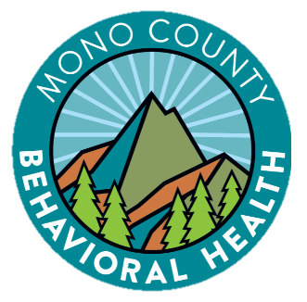

Mono County
Behavioral Health

Cultural and Linguistic Competence Plan
Submitted December 2025 & Includes Goals for FY 2025-2026

Contents
Overview 3
Criterion 1: Commitment to Cultural and Linguistic Competence 4
Criterion 2: Updated Assessment of Service Needs 6
Criterion 3: Strategies and efforts for reducing racial, ethnic, cultural, and linguistic mental health disparities 17
Criterion 4: Client/Family Member/Community Committee: Integration of the Committee within the County Mental Health System 24
Criterion 5: Culturally Competent Training Activities (FY 2024-2025) 27
Criterion 6: County’s commitment to a growing multicultural workforce: hiring and retaining cultural and linguistically competent staff 32
Criterion 7: Language Capacity 34
Criterion 8: Adaptation of Services 36

Name of County: | Mono
Name of County Mental Health Director: | Robin K. Roberts
Telephone Number: | 760-924-1740
Email address: | rroberts@mono.ca.gov
Mailing Address: | PO Box 2619  Mammoth Lakes CA 93546
Physical Address: | 1290 Tavern Road, 2nd Floor  Mammoth Lakes CA 93546

Mono County Behavioral Health (MCBH)

Vision:
Our vision is to promote healthy living and improve the quality of life in our community.

Mission:
Our mission is to encourage healing, growth, and personal development through whole person care and community connectedness. Our services are strength based and client centered; we strive to create a safe environment and serve all with dignity, respect, and compassion.

Overview

Mono County Behavioral Health (MCBH) endeavors to deliver culturally, ethnically, and linguistically appropriate services to behavioral health clients and their families in a competent manner that is responsive to diverse cultural beliefs, practices, preferred languages, and reflects the health beliefs and practices of the communities we serve. This vision is reflected in our world view, informing materials, and client treatment plans. Integration of these values creates a forum for ensuring that we continually enhance our services to be culturally and linguistically relevant for our youth and adult clients and their families. Staff members continually discuss opportunities to promote and improve the delivery of culturally-sensitive and relevant services.

MCBH’s vision and mission include providing understandable, equitable, effective and respectful services while recognizing the importance of developing services that exhibit cultural humility and are sensitive to customs, cultures, ethnic groups, persons with disabilities, consumers in recovery (from mental health or substance use), lesbian, gay, bisexual, transgender, questioning, intersex, and two-spirit (LGBTQI2-S) individuals, various age groups (Transition Age Youth - TAY: Older Adults), faith-based, physically disabled, and persons involved in the correctional system.

Fostering and developing a culturally and linguistically competent system requires ongoing training and education in which we continually learn from each other and entails the dedication, commitment and perseverance from leadership, staff, and the community.

The following Cultural and Linguistic Competence Plan (CLCP) signifies our continuing commitment to improving access to services, quality care, and improving outcomes. The CLCP addresses the requirements from the Department of Health Care Services (DHCS) for both Mental Health and Alcohol and Other Drug services, including the Cultural and Linguistic Standards (CLAS).

Criterion 1: Commitment to Cultural and Linguistic Competence

MCBH is committed to constantly improving services to meet the needs of culturally diverse individuals seeking and receiving services. A number of objectives were developed as a component of our Mental Health Services Act (MHSA) Plan and have been expanded as we have integrated Substance Use Disorder (SUD) Treatment Services into our program.

I. County mental health commitment to cultural competence
The practices outlined below help provide the framework for developing this CLCP. MCBH believes that these practices, which are also reflected in the Department’s cultural competence policies, reflect the department’s steps taken to fully incorporate the recognition and value of racial, ethnic, and cultural diversity and equity within the County Mental Health System.

- Our mission is to encourage healing, growth, and personal development through whole person care and community connectedness. Our services are strength based and client centered; we strive to create a safe environment and serve all with dignity, respect, and compassion.
- To expand the behavioral health workforce by recruiting, promoting, training, and supporting culturally and linguistically diverse leadership and workforce of staff, consumers, TAY, and family members that is responsive to our community needs.
- To provide culturally and linguistically appropriate behavioral health services, and easy to understand informing materials in our threshold languages (Spanish and English), to the community, and to improve access for persons who are Hispanic/Latinx, Native/Indigenous, and other race/ethnicity groups; transitional age youth (TAY) and older adults; veterans; lesbian, gay, bisexual, transgender, questioning, intersex, and two-spirit (LGBTQI2-S) individuals; persons released from jail; homeless; additional cultures; and family members.
- To deliver behavioral health services to clients and family members in their primary language whenever possible, including language assistance at no cost to the consumer.
- To gather and sustain a robust cultural outreach committee including members from Mono County’s diverse communities.
- To offer cultural competence training programs for behavioral health staff and collaborative community partners.
- To deliver behavioral health services in collaboration with other community organizations and co-locate services whenever possible, including in diverse community settings (e.g., churches, senior centers, schools, family resource centers, wellness center and other rural community locations).
- To develop outreach and education activities focused on providing information about mental health services for groups and organizations known to serve the Hispanic/Latinx and Native communities in the least restrictive environment (e.g., Tribal Community, churches, etc.).
- To promote the delivery of culturally competent services through the expansion of the behavioral health Quality Improvement Committee (QIC), the Cultural Outreach Committee (COC), and other committees in order to increase the proportion of persons who reflect the diversity of the county, for example expanding membership for persons who are Hispanic/Latinx, Native/Indigenous, TAY, LGBTQI2-S, older adults and veterans.
- To collect and maintain accurate and reliable demographic and service-level data to monitor and evaluate the impact of services on health equity and outcomes.
- To create and support a culturally safe environment to promote understanding, equity, and positive communication.

II. County recognition, value, and inclusion of racial, ethnic, cultural, and linguistic diversity within the system

Mono County reflects less diversity than the larger counties or even neighboring counties in the central region. However, Mono recognizes the importance of creating systems, which include and target all cultural, ethnic and socio-economic groups.

As stated above, Mono County solicits input annually from the Cultural Outreach Committee (COC) to identify needs and develop goals and objectives that target the underserved ethnic populations in the community. In addition to identifying ethnic populations, the COC focuses on sub-populations in isolated rural areas as well as countywide. Since Mono County is not an ethnically diverse community, other identified populations allow the County to focus on other areas of culture that need to be addressed such as poverty, homelessness, Veterans, LGBTQ, Older Adults and Foster Youth.

III. County designated Equity Services Manager (ESM)

Mono County has designated staff who fulfill the duties of an Equity Services Manager (ESM) and are responsible for MCBH’s specific efforts related to cultural and linguistic competence. This duty was fulfilled primarily by a Behavioral Health Services Coordinator and the department’s Racial Equity Committee, which is made up of a rotating set of staff from positions throughout the department. The Program Manager and the Program Manager of Clinical Services assisted in completing the CLCP. Staff also participate in state- and regional-level ESM groups.

The responsibilities of the ESM are to incorporate cultural competence practices at every level within MCBH and MCBH provider networks. The ESM is to use stakeholder input to identify cultural competence objectives and goals that include the county’s racial, ethnic, cultural, and linguistic populations. The ESM is also responsible for providing this information to the MCBH QI and Leadership teams to promote cohesive inclusion of all cultural and linguistically appropriate access and service delivery within all levels of the organization. The ESM will work closely with QI to ensure that policies, procedures, access, service delivery, and trainings are all culturally sensitive and appropriate.

It is also the responsibility of the ESM to work with the Cultural Outreach Committee (COC) maintain and update the Cultural and Linguistic Competency Plan on an annual basis.

IV. Budget resources targeted for culturally competent activities

The budget for FY 24-25 and FY 25-26 is included below. In addition to the activities below, the Department funds the ESM position and a supervisor’s time, as well as staff time to plan and execute each activity below.

Activities | Total Budgeted
Foro Latino | $3,000
Other Cultural Outreach | $1,600
Training for MCBH Staff | $16,000

Criterion 2: Updated Assessment of Service Needs

I. General Population

Mono County is a frontier county located in the east central portion of the state of California and is the fifth least populous county in California. It is bordered to the east by the state of Nevada and is approximately 3,048 square miles. The county is geographically diverse and consists of a large land area that includes lakes, desert areas, and dense forests/forest service land. The county seat is Bridgeport and the only incorporated town in the county is Mammoth Lakes.

Many of the neighborhoods in Mono County consist of only residences and do not have community services such as gas stations, grocery stores, etc. The northern part of the county encompasses the small towns of Topaz, Coleville and Walker. Bridgeport, the county seat, is 35 miles south of these three small communities. The central part of the county includes the communities of Lee Vining, Mono City, June Lake, Crowley Lake, the Wheeler Crest communities (Swall Meadows, Paradise, Aspen Springs, McGee Creek, Long Valley) and Mammoth Lakes. In the southeast sector lie Benton, Hammil (Hammil Valley), and Chalfant (Chalfant Valley).
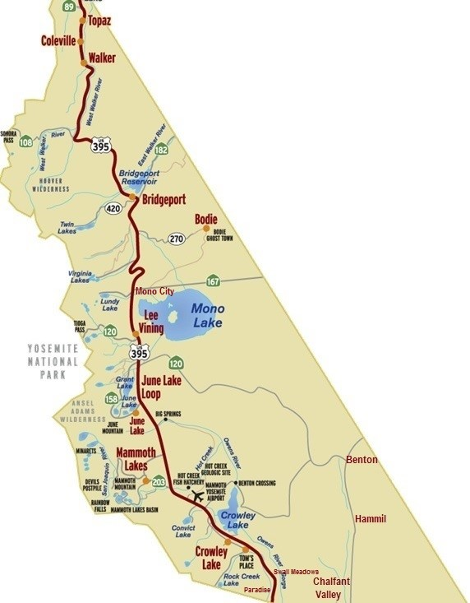

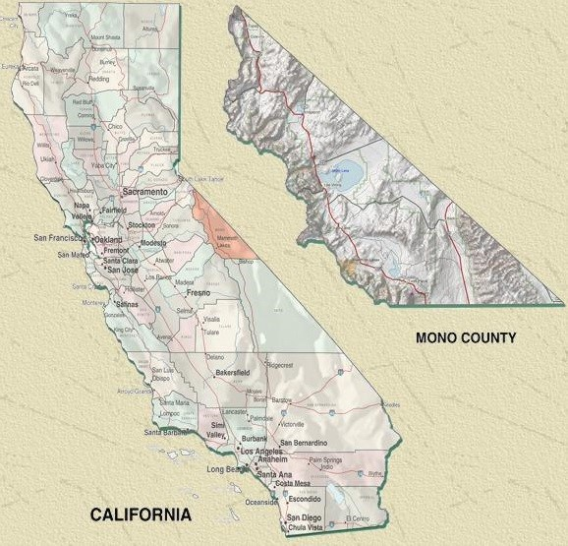
Most residents of Mono County live at elevations between 5,000 to 8,500 feet, with the center of the town of Mammoth Lakes at an elevation of approximately 7,880. Winters are often long and harsh, with occasional road closures, and summers are brief. Within the county, near the Town of Mammoth Lakes is Mammoth Mountain Ski Area, a popular winter vacation site and one of the top skiing/snowboarding destinations in California. During the 2022-2023 season, snowfall at the ski area’s Main Lodge hit a record 700 inches (over 58 feet) of snow.

Residents primarily earn their livelihood through government service, service industry jobs, and retail trades related to tourism and agriculture. Several of Mono County’s communities are year-round resorts and include a number of multi-million-dollar homes belonging to second homeowners. However, many year-round residents struggle to make ends meet, often having more than one job.

Schools for the County are located in Coleville, Bridgeport, Lee Vining, Benton, and Mammoth Lakes, each 25-45 miles from the next. Mono County has two school districts: Mammoth Unified and Eastern Sierra Unified.

According to The United States Census Bureau Quick Facts statistics, the total population of Mono County is 13,105. Other than Mammoth Lakes, which has a year-round population of approximately 7,191, the remainder of the county consists of small rural communities ranging in population from less than 300 to about 1,200 people. To illustrate the vastness of the county, once might conceptualize this by understanding there are approximately 4.1 people per square mile.

The ethnic distribution of Mono County is 27 percent Hispanic/Latinx, 2 percent Native American and Alaska Native, 2 percent Asian, 0 percent Black or African American, 0 percent Native Hawaiian/Other Pacific Islander/Other/Unknown, and 66 percent White alone, not Hispanic, or Latinx. The county is comprised of 44% percent female residents and 56 % percent male residents. There are 635 veterans. Figure 1 shows populations by counts and percentages categorized by race, gender, and age.

With the aim to identify and address potential disparities, MCBH utilizes data sources including, but not limited to, the National Healthcare Effectiveness Data and Information Set, the California Mental Health Services Authority’s Descriptive Analysis Report, penetration rate data from the California External Quality Review Organization, and local county data, such as the MHSA Community Program Planning Process data.

Figure 1
Mono County Residents
By Gender, Age, and Race/Ethnicity
(Population Source: Census Reporter V2023)

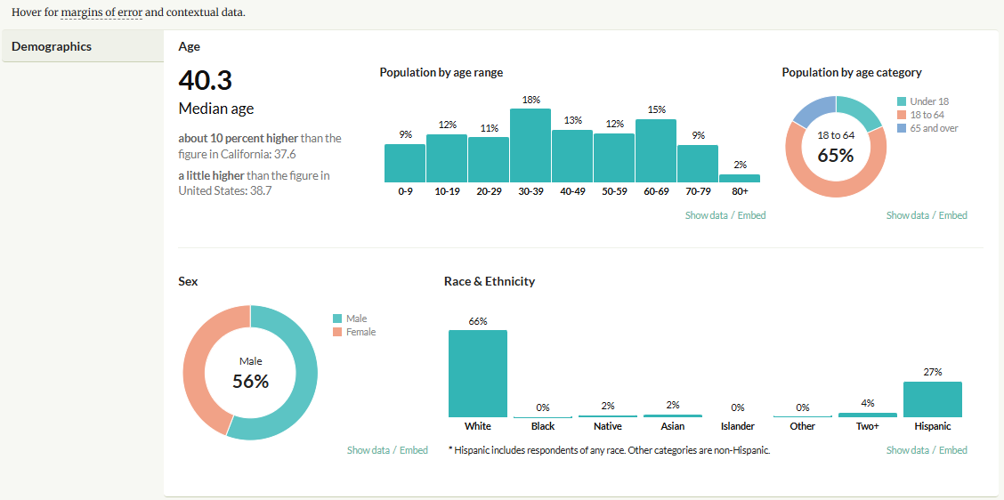
II. Medi-Cal Population Service Needs

The tables and graphs below provide information about Mono County’s Medi-Cal members, services rendered/claims processed, and penetration rates

Table 1: County Medi-Cal Beneficiaries and Those Served by the MHP in CY 2021 by Race/Ethnicity, including Penetration Rates (PR)

Race/Ethnicity | Annual Eligibles | Beneficiaries Served | PR MHP | PR State
African-American | 17 | 4 | 23.53% | 7.08%
Asian/Pacific Islander | 35 | 0 | 0.00% | 1.91%
Hispanic/Latino | 1,840 | 56 | 3.04% | 3.51%
Native American | 101 | 1 | 0.99% | 5.94%
Other | 497 | 31 | 6.24% | 3.57%
White | 1,409 | 114 | 8.09% | 5.45%
Total | 3899 | 206 | 6.98% | 4.58%

Table 2: County Medi-Cal Beneficiaries and Those Served by the MHP in CY 2021 by Threshold Language

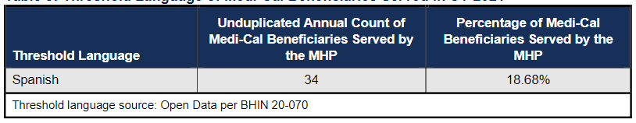
Table 3: SMHS Penetration Rates by County FY2023: Youth
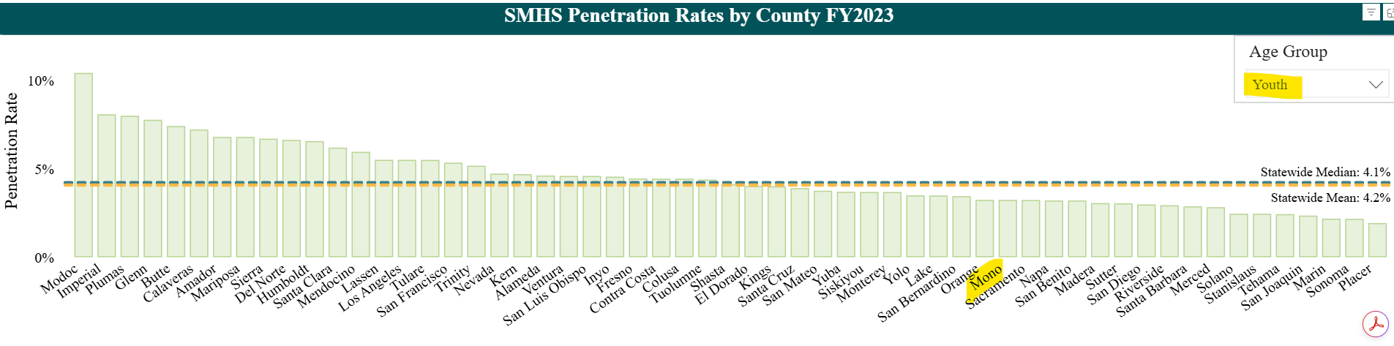
Table 4: SMHS Penetration Rates by County FY2023: Adults
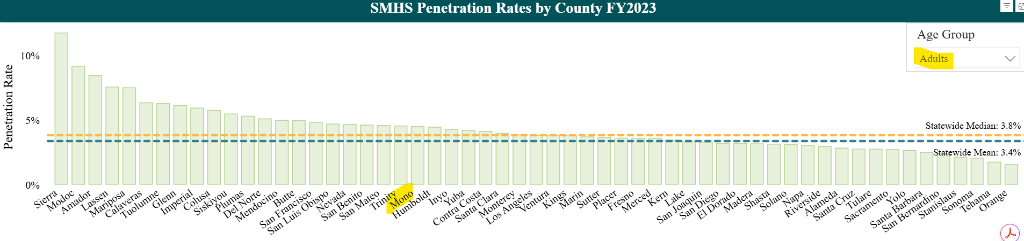
Penetration Rates and Annual Approved Claims per Beneficiary (AACB)
Figure 1: Overall Penetration Rates CY 2022

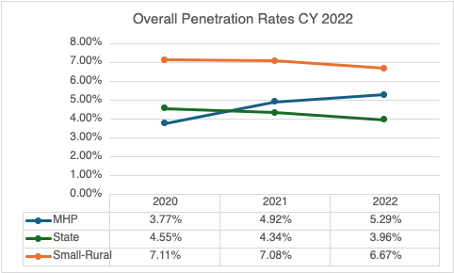

Figure 2: Overall AACB CY 2022
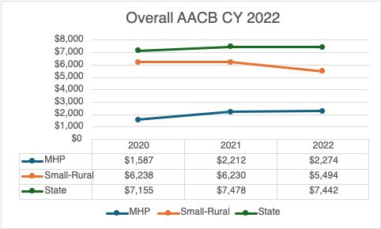
Note that in FY 24-25, Mono’s average charge per client was $2,718

Figure 3: Latino/Hispanic Penetration Rates CY 2022
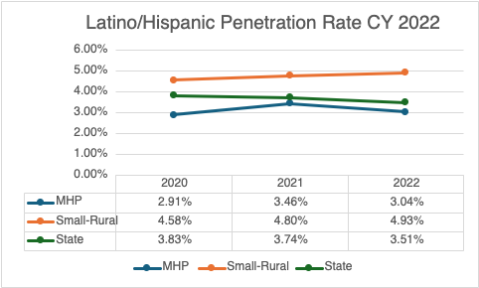

Figure 4: Latino/Hispanic AACB CY 2022
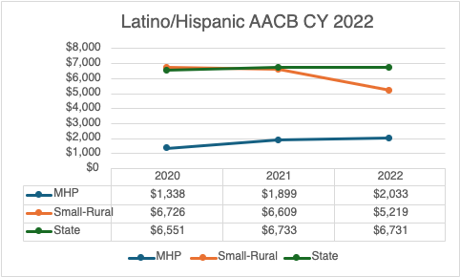

Figure 5: Foster Care Penetration Rates CY 2022
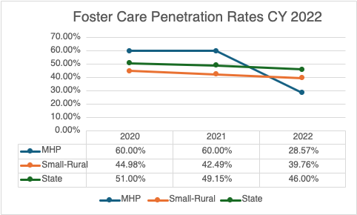

Figure 6: Foster Care AACB CY 2019-21
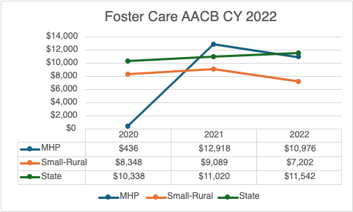

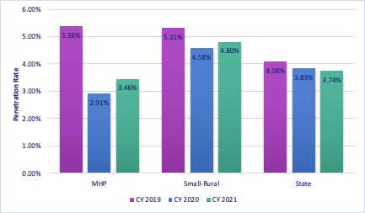

III. 200% of Poverty (minus Medi-Cal) population and service needs

Mono County’s per capita income estimate for 2023 is $49,271 (source: U.S. Census). This is higher than the statewide per capita income of $47,977.

For median household income, the U.S. Census lists median household income in Mono County at $86,953, which is approximately 10 percent lower than the State household income of $96,334.

The U.S. census for the same time period indicated above list that 11 percent of Mono County residents live in poverty vs. 12 percent across California. The median value of owner-occupied housing units is $514,300 vs. $695,400 across California.

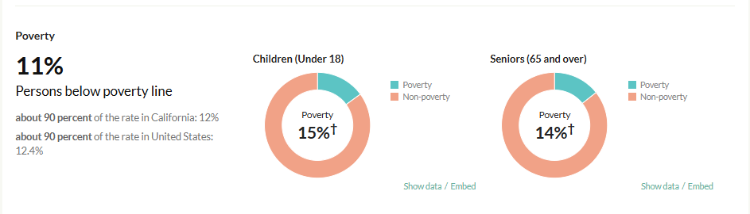

IV. MHSA Community Services and Supports (CSS) population assessment and service needs
Please refer to the FY 23-26 Mental Health Services Act Three-Year Plan, which is available at this link:
https://www.monocounty.ca.gov/sites/default/files/fileattachments/behavioral_health/page/10057/mono_mhsa_fy_23-24_24-25_25-26_three_year_plan_final.pdf

Please refer to the FY 24-25 Mental Health Services Act Annual Update, which is available at this link:
https://monocounty.ca.gov/sites/default/files/fileattachments/behavioral_health/page/34049/mono_mhsa_fy_24-25_annual_update_final_approved_by_bos.pdf
V. Prevention and Early Intervention (PEI) Plan: The process used to identify the PEI priority populations
Please refer to the FY 23-26 Mental Health Services Act Three-Year Plan, which is available at this link:
https://www.monocounty.ca.gov/sites/default/files/fileattachments/behavioral_health/page/10057/mono_mhsa_fy_23-24_24-25_25-26_three_year_plan_final.pdf

Please refer to the FY 24-25 Mental Health Services Act Annual Update, which is available at this link:
https://www.monocounty.ca.gov/sites/default/files/fileattachments/behavioral_health/page/34049/mono_mhsa_fy_24-25_annual_update_final_approved_by_bos.pdf

Criterion 3: Strategies and efforts for reducing racial, ethnic, cultural, and linguistic mental health disparities

I. Identified unserved/underserved target populations and identified inequities

We know culture plays an essential role in how clients and their families define mental health and respond to the services offered by mental health providers. Cultural competency, and also cultural humility, produces better care and better outcomes for the people we serve. This includes our staff being able to identify cultural differences with each other, community members and consumers. MCBH continually strive to provide information regarding “competency” about cultures that may differ from our own: Hispanic/Latinx persons and how there are cultural differences within this demographic, persons living in poverty, persons attracted to the loner/independent/off-the-grid lifestyle, as well as Native America persons who come from the different reservations in our county, multi-generational families who have lived in this Frontier county, etc.

With competency and humility as our goal, there are a number of obstacles that we continue to face due to the size and nature of our county.

- Staffing: Like workplaces across the country, MCBH is constantly working to recruit and retain. Although the team is nearly fully staffed, with new initiatives coming down from the state at a rapid pace, Mono has trouble keeping up, which increases the risk of burn-out among all staff members. MCBH has worked hard to hire qualified personnel to reflect the County’s culturally and linguistically diverse community, and we feel strongly that, when at all possible, our staff ought to mirror the ethnic demographics of our county and our clients.

- Training: Due to our remote location, and small staff size, paying for, and incentivizing outside trainers who are skilled at cultural competency and/or have knowledge about the culture of the people in Mono County has been difficult in the past.

- Community: Our county is spread over a large geographical area, and the community in the north of our county is very different than that in the south of the community. The services that are provided in Mammoth Lakes, and how we outreach to people in that town, has to be very different from how we engage and serve our outlying areas of the county. Outreach to our Native/Indigenous community has been a barrier for MCBH in the past and therefore continues to be one of our priorities.

II. Identify strategies/objectives/actions/timelines for FY 2025-2026
- The following objectives have been identified to promote the development of culturally and linguistically competent services throughout our organization.

Goal 1: MCBH will provide culturally and linguistically appropriate behavioral health services to improve access for persons who are Native/Indigenous, Hispanic/Latinx and other race/ethnicity groups; TAY and older adults; veterans and their families; lesbian, gay, bisexual, transgender, questioning, intersex, and two-spirit (LGBTQI2-S) individuals; persons released from jail and their families; and physical disabilities.
- Objective 1a: MCBH will provide informing materials in English and Spanish in our clinics and wellness centers.
- Objective 1b: When appropriate, MCBH will hire and retain diverse or bilingual staff to work in our programs in order to provide services and information to the client and family in their preferred language and preferred cultural setting.
- Objective 1c: MCBH will ensure that the crisis line is culturally-sensitive to all persons utilizing these services, and clients receive services in their preferred language.
- Objective 1d: Trainings for interpreters to ensure that MCBH’s bilingual staff have professional development opportunities related to the use of profession-related terminology in Spanish.
- Objective 1e: Annual re-training for all staff on how to use an interpreter to ensure that the client experience of having an interpreter is welcoming and clear.
- Objective 1f: Annual re-training of all staff on cultural competence, focusing on the CLAS standards.
- Objective 1g: Monitoring of contract providers (staff of North American Mental Health Services) to ensure they receive annual cultural competence training.
Notable changes: Objective 1d was changed to demonstrate more relevant Spanish terms associated with the professions of those within Mono County Behavioral Health. In objectives 1e and 1f “annual re-training” was added as part of each objective.

Goal 2: MCBH will create a work culture that values justice, equity, diversity, and inclusion through staff cultural competence training, dialogue, and other professional development opportunities.
- Objective 2a: In FY 2025-2026, all MCBH staff will devote one percent of their time to continuing education promoting racial justice, equity, diversity, and inclusion. The format of this work will change over the course of the year to ensure ongoing staff engagement in the work.
- Objective 2b: MCBH will offer at least one training or focus one month of continuing education on Native/Indigenous culture.
- Objective 2c: MCBH will train staff regarding LGBTQA+ related issues on access, stigma, and therapeutic needs through either a training or a continuing education focus.
- Objective 2d: MCBH staff will participate in state and community groups focused on justice, equity, diversity, inclusion, and cultural competence. Some examples may include on the California Behavioral Health Directors’ Association (CBHDA) Cultural Competency, Equity, and Social Justice Committee and the Eastern Sierra Pride group.
- Objective 2e: MCBH will include a cultural competence and racial equity overview in the onboarding process for every new employee.
- Objective 2f: The MCBH Equity Committee will continue to meet, create the equity work plan, and ensure the activities of the work plan are completed.
- Objective 2g: Every interview conducted by MCBH will have at least one question focused on justice, equity, diversity, and inclusion.

Notable changes: Changed language related to Objective 2e.

Goal 3: MCBH will provide services in culturally-appropriate and accessible ways. MCBH recognizes that due to cultural and/or other socio-economic barriers that exist within our county, utilizing the public behavioral health system may not be a viable option for some clients and their family members.
- Objective 3a: MCBH will deliver services in the most accessible ways (e.g., telehealth, home, schools, tribal community, senior center, and other rural community locations) when needed and as appropriate.
- Objective 3b: MCBH will provide outreach and engagement with local Tribal community members, including those working in the mental health/substance use disorder profession, including more formalized partnerships with organizations such as the Owens Valley Career Development Center and TANF in Antelope Valley.
- Objective 3c: MCBH will work closely with local school districts (Eastern Sierra Unified School District and Mammoth Unified School District) to prevent alcohol and drug use and intervene early in the onset of behavioral health issues.
- Objective 3d: MCBH will hold meetings with other agencies and programs to discuss and plan culturally competent services that promote community wellbeing.
- Objective 3e: Identify opportunities for collaboration in the Spanish-speaking community (i.e. Latinx/Hispanic community events, etc.) to provide outreach with an emphasis on mental health and wellbeing.
Notable changes: N/A

Goal 4: MCBH will create and maintain a strong and relevant Cultural Outreach Committee (COC) to serve as a space for learning, idea-sharing, and community connection.
- Objective 5a: Work with the COC to ensure a clear mission and purpose for the group.
- Objective 5b: Include Native Community Members on the COC.
- Objective 5c: Consider other ideas for recruitment and retention of COC members.
- Objective 5d: Identify avenues for collaboration with community agencies participating in the COC, including joint wellness activities and community-wide equity training and events throughout Mono County.
Notable Changes: N/A

III. Planning & monitoring of identified strategies/objectives/actions/timelines to reduce mental health inequities: evaluation of FY 24-25 goals & objectives

The goals and objectives below are from the previous CLCP from FY 2024-2025. Through these goals and objectives, MCBH has worked tirelessly to provide culturally-specific services to meet the needs of diverse populations, including peer-driven services.

Goal 1: MCBH will provide culturally and linguistically appropriate behavioral health services to improve access for persons who are Native/Indigenous, Hispanic/Latinx and other race/ethnicity groups; TAY and older adults; veterans and their families; lesbian, gay, bisexual, transgender, questioning, intersex, and two-spirit (LGBTQI2-S) individuals; persons released from jail and their families; and physical disabilities.
- Objective 1a: MCBH will provide informing materials in English and Spanish in our clinics and wellness centers. MET
- Objective 1b: When appropriate, MCBH will hire and retain diverse or bilingual staff to work in our programs in order to provide services and information to the client and family in their preferred language and preferred cultural setting. MET
- Objective 1c: MCBH will ensure that the crisis line is culturally-sensitive to all persons utilizing these services, and clients receive services in their preferred language. MET
- Objective 1d: Trainings for interpreters to ensure that MCBH’s bilingual staff have professional development opportunities related to the use of terminology and medical Spanish. MET
- Objective 1e: Training for all staff on how to use an interpreter to ensure that the client experience of having an interpreter is welcoming and clear. MET
- Objective 1f: Training of all staff on cultural competence, focusing on the CLAS standards. MET
- Objective 1g: Monitoring of contract providers (staff of North American Mental Health Services) to ensure they receive annual cultural competence training. MET
Current Status as of December 2025:
- MCBH offers all informing materials and other critical documents in both English and Spanish and the department has a diverse staff that is approximately 44% bilingual English/Spanish speakers. Additional languages spoken among staff members include Korean and Mandarin.
- In the event that a bilingual staff member is not available for a crisis, and interpretation services are needed, staff are trained in the use of an interpreter and have access to the Language Line.
- MCBH continually strives to expand the number of services we have available in Spanish in an effort to continue to improve mental health access for Hispanic/Latinx and monolingual Spanish speaking clients.
- All MCBH staff members received training on how to use an interpreter and all bilingual staff members received training on how to serve as an interpreter in Fall of 2023, Fall of 2024 and Fall of 2025.
- MCBH will have trained all staff on the CLAS standards in December 2023, December 2024 and December 2025.
- MCBH ensured that its contract provider, North American Mental Health Services, completed its annual cultural competence training for FY 24-25.

Goal 2: MCBH will create a work culture that values justice, equity, diversity, and inclusion through staff cultural competence training, dialogue, and other professional development opportunities.
- Objective 2a: In FY 2024-2025, all MCBH staff will devote one percent of their time to continuing education promoting racial justice, equity, diversity, and inclusion. The format of this work will change over the course of the year to ensure ongoing staff engagement in the work. MET
- Objective 2b: MCBH will offer at least one training or focus one month of continuing education on Native/Indigenous culture. MET
- Objective 2c: MCBH will train staff regarding LGBTQA+ related issues on access, stigma, and therapeutic needs through either a training or a continuing education focus. MET
- Objective 2d: MCBH staff will participate in state and community groups focused on justice, equity, diversity, inclusion, and cultural competence. Some examples may include on the California Behavioral Health Directors’ Association (CBHDA) Cultural Competency, Equity, and Social Justice Committee and the Eastern Sierra Pride group. MET
- Objective 2e: MCBH will include a cultural competence and racial equity overview in every new employee onboarding process. MET
- Objective 2f: The MCBH Equity Committee will continue to meet, create the equity work plan, and ensure the activities of the work plan are completed. MET
- Objective 2g: Every interview conducted by MCBH will have at least one question focused on justice, equity, diversity, and inclusion. MET

Current Status as of December 2025:
- MCBH staff members devoted one percent of their time by participating in a range of trainings both internally and externally led. One of the highlights of equity work in 2024 was participating in a series of trainings with Ebony Chambers McClinton, a stand-out DEI trainer who created a warm environment for learning about these critical issues. Staff members also participate in monthly self-guided continuing education and all staff are trained in cultural competence and equity during their onboarding process.
- In FY 24-25, MCBH focused on Native/Indigenous culture as one of its continuing education months. The Department also focused on LGBTQ+ communities for one of its continuing education months. Additionally, clinical staff received training on LBGTQ+ stigma during its clinical supervision as part of a series of trainings hosted by Director Robin K. Roberts.
- MCBH included a cultural competence and racial equity overview in every new employee onboarding process and asked a question about justice, equity, diversity, and inclusion in every interview it conducted.
- The MCBH Equity Committee continued to meet throughout the year to ensure that the activities in the Equity Workplan are being met or worked towards. They also adapted activities such as the ongoing monthly continuing education to ensure that staff are actively engaged with the activity.
- In February of 2025, a new ESM was assigned and has been working since to continue efforts that the previously ESM had been working on.

Goal 3: MCBH will provide services in culturally-appropriate and accessible ways. MCBH recognizes that due to cultural and/or other socio-economic barriers that exist within our county, utilizing the public behavioral health system may not be a viable option for some clients and their family members.
- Objective 3a: MCBH will deliver services in the most accessible ways (e.g., telehealth, home, schools, tribal community, senior center, and other rural community locations) when needed and as appropriate. MET
- Objective 3b: MCBH will provide outreach and engagement with local Tribal community members, including those working in the mental health/substance use disorder profession, including more formalized partnerships with organizations such as the Owens Valley Career Development Center and TANF in Antelope Valley. MET
- Objective 3c: MCBH will work closely with local school districts (Eastern Sierra Unified School District and Mammoth Unified School District) to prevent alcohol and drug use and intervene early in the onset of behavioral health issues. MET
- Objective 3d: MCBH will hold meetings with other agencies and programs to discuss and plan culturally competent services that promote community wellbeing. MET
- Objective 3e: Identify opportunities for collaboration in the Spanish-speaking community (i.e. Latinx/Hispanic community events, etc.) to provide outreach with an emphasis on mental health and wellbeing. MET
Current status as of December 2025:
- MCBH continuously works to deliver services in the most accessible environment possible. MCBH continues to offer telehealth services since we have anecdotally found that it has increased access for a variety of different groups of people, including members of the Latinx community and individuals who live in our outlying areas. In November and December 2023, MCBH conducted a client satisfaction survey to quantitatively measure satisfaction with telehealth services and overall access to services.
- In terms of community programming, MCBH has continued to provide several wellness activities that focuses on Older/Aging Adults, Tribal Members, LGBTQIA+ and Latinx community members. The department again hosted several Foro Latino events specifically focused on the Latinx community in the FY 24/25. MCBH also partnered with Mono Arts Council and the Bridgeport Indian Colony to host several art nights and socials featuring Native artisans and hosts Wellness programming on Tribal Lands monthly. MCBH participates in Health and Safety Fairs and other community events throughout the county. Finally, during the 24/25 school year, MCBH hosted a group on a local school campus that was ran by a Psychotherapist. This group called “Lavender” was focused on creating supportive spaces for LGBTQ+ community members.
- MCBH continued weekly outreach to the Walker Senior Center (lunch, games, chair yoga) and continued to collaborate with the Department of Social Services to expand the “Granpad program,” which provides tablets to older adults.
- MCBH regularly engages with Tribal community members through clinical, substance use disorder, wellness, and cultural outreach related work. MCBH staff have also partnered with the Bridgeport Indian Colony to conduct Narcan distribution on the reservation.
- MCBH continues to host the “Benton Social,” which takes place on the Benton Paiute Reservation and includes collaboration with the Toiyabe Elder Services program. The Bridgeport Social alternates locations between Bridgeport Indian Colony and Memorial Hall. There is continued participation by the Department on seasonal Tribal gatherings and outreach, as well as the annual Kutzadika'a days celebration. Collaborated with TANF and OVCDC on Mental Health Month outreach events.
- In terms of youth outreach, MCBH has an after-school program called Clubhouse Live, and it is offered to youth in Bridgeport and Mammoth Lakes. Through Clubhouse Live, students provide input on departmental community programming.
- MCBH’s Cultural Outreach Committee is a group that regularly discusses cultural competence in an effort to promote community wellbeing. MCBH also gathers input from both agencies and individuals through its annual MHSA Community Program Planning Process.

Goal 4: MCBH will create and maintain a strong and relevant Cultural Outreach Committee (COC) to serve as a space for learning, idea-sharing, and community connection.
- Objective 5a: Work with the COC to ensure a clear mission and purpose for the group. MET
- Objective 5b: Include Native Community Members on the COC. MET
- Objective 5c: Consider other ideas for recruitment and retention of COC members. MET
- Objective 5d: Identify avenues for collaboration with community agencies participating in the COC, including joint wellness activities and community-wide equity training and events throughout Mono County. MET
Current Status as of December 2025:
- The COC continues to have a clear purpose as a group of peers pushing JEDI work forward through the County. The group also focuses on cross-collaboration for events and a pooling of resources for future trainings.
- MCBH has regular engagement with the Tribal member who sits on the COC and ongoing collaboration with other events and outreach.
- MCBH and MAC also collaborated to facilitate Powwow Community Dance classes and other art events with Native artisans.

Criterion 4: Client/Family Member/Community Committee: Integration of the Committee within the County Mental Health System

The Cultural Outreach Committee (COC) meets every other month and spends a significant amount of time discussing potential outreach options to ensure the health and safety of our diverse residents. In the past year, the COC has worked diligently in collaborating with various businesses and agencies and regularly has attendance, participation and alliance with these entities. Committee members have been incorporating members of underserved groups into their agencies and programming as part of their commitment to the COC. Lastly, the COC also includes contributions from clients and family members of clients whenever possible.

- The Cultural Outreach Committee is reflective of the community

The MCBH Equity Services Manager (ESM) monitors all activities pertaining to the COC and provides technical support. The ESM is overseeing the development of the CLCP and is a member of the Equity Committee; the Equity committee was established after Mono County passed the resolution that addressed mental health as crisis. This committee is to address justice, equity, diversity, and inclusion within the county and community. This committee facilitates communication and collaboration for attaining the goals as set forth in the CLCP. Plan to reduce disparities, increase capacity, and improve the quality and availability of services.

The Mono County Cultural Outreach Committee works closely to ensure compliance to the CLCP and include recommendations in its implementation and development. In addition, the ESM attends all COC and BHAB meetings (Behavioral Health Advisory Board). The COC will in future participate in MHSA planning processes. The Cultural Outreach Committee will continue to meet every other month and track their activities so that projects, activities and policy issues are clearly communicated to the ESM.

Cultural Outreach Committee Roster:

Lori Michelon- Crowley Library
Lauren Plum -Behavioral Health
Rachel Barnett - Mono County Health Department, Health Equity Officer
Tajia Rodriguez - Peer Support/ Case Manager- Mono County Behavioral Health
Samara Moschiano -Community Support Solutions
Marjoree Neer Mono- County Public Health Nurse Manager
Kristin Reese- Mono Arts Council & Mountain Queers
Esther Hampton- Tribal Assistance for Needy Families
Rachel Shay- Mammoth Mountain Community Foundation
Betsy Truax- Mammoth Lakes Tourism
Brianna Goico -Mammoth Lakes Chamber of Commerce
Jannette Colon- Bridgeport Indian Colony
Jolene Carly- Benton Tribal Office
Rose Delgato- Bridgeport Business Owner
Rhonda Kauk- Kootzaduka'a Lake Tribal Member
Joseph Lent -Bridgeport Indian Colony Member
Emily Mendez -First 5, Mono Arts Council, Bridgeport Library
Michelle Raust -Social Services
Jesica Ramos -Behavioral Health
Marcy Castro -Chamber of Commerce
Brooke Rogers - Mono Arts Council
Ceanne Faustini -Mammoth Library
Daisy Lopez -Health and Human Services

Leadership
The COC is led by department Equity Service Manager (ESM). In 2021, and continuing into 2025, the committee decided to meet every other month so there are 6 meetings throughout the year.
The roles and responsibilities of the ESM include:
- Facilitate all meetings
- Engage members in Committee discussions
- Collaborate with the COC in the development of meeting agendas
- Communicate the focus of the COC activities and recommendations made to diverse MCBH entities

Event | Number of Attendees | Name of Attendees | Length of meeting | Date
Cultural Outreach Committee | 6 | Lori Michelon  Rachel Barnett  Tajia Rodriquez  Samara Moschiano  Lauren Plum  Marjoree Neer | 90 Minutes | 7/09/24
Cultural Outreach Committee | 15 | Lori Michelon  Rachel Barnett  Tajia Rodriguez  Samara Moschiano  Marjoree Neer  Kristin Reese  Esther Hampton  Rachel Shay  Betsy Truax  Brianna Goico  Jannette Colon  Jolene Carly Benton  Rose Delgato  Rhonda Kauk  Joseph Lent | 90 Minutes | 9/9/2024
Cultural Outreach Committee | 5 | Emily Mendez  Kritin Reese  Marjoree Neer  Michelle Raust  Tajia Rodriquez | 120 Minutes | 12/17/24
Cultural Outreach Committee | 6 | Tajia Rodriquez  Jesica Ramos  Marcy Castro  Ceanne Faustini  Kristin Reese  Lori Michelon | 60 Minutes | 2/25/2025
Cultural Outreach Committee | 5 | Jesica Ramos  Tajia Rodriquez  Emily Mendez  Kristin Reese  Marjoree Neer | 49 Minutes | 6/24/2025
Cultural Outreach Committee | 6 | Jesica Ramos  Marjoree Neer  Lori Michelon  Tajia Rodriquez  Ceanne Faustini  Emily Mendez | 61 Minutes | 8/26/25
Cultural Outreach Committee | 6 | Brooke Rogers  Jesica Ramos  Daisy Lopez  Marjoree Neer  Tajia Rodriquez  Emily Mendez | 60 Minutes | 10/28/25

Criterion 5: Culturally Competent Training Activities (FY 2024-2025)

MCBH is committed to embedding cultural competence and cultural humility into all training activities within the agency and to the community.

In addition, the ESM attends regular webinar trainings on topics related to cultural competence. All webinar opportunities are distributed to MCBH staff members and community partners in order to increase their education, awareness and skills around all elements of culture.

This section describes cultural competence training for staff and contract providers, including training in the use of interpreters.

List of internal training and staff attendance by function:
- Administration/management;
- Direct services: MHP’s staff;
- Direct services: contactors;
- Support services; and,
- Interpreters.

Training Event | Attendees by Function | Date
Stigma of Mental Health in Latin Communities and Immigrant Trauma | Director  Clinical Supervisor  SUD Supervisor  Program Manager  Accountant  Staff Services Analysts  Behavioral Health Services Coordinators  Case Managers  Fiscal Technical Specialists  Wellness Center Associates  SUD Counselor  Psychiatric Specialists | 7/24/24
Equity Training with Ebony Chambers | Director  Clinical Supervisor  SUD Supervisor  Program Manager  Accountant  Staff Services Analysts  Behavioral Health Services Coordinators  Case Managers  Fiscal Technical Specialists  Wellness Center Associates  SUD Counselor  Psychiatric Specialists | 7/30/24
Burn-out and self-care, especially after a crisis | Director  Clinical Supervisor  SUD Supervisor  Program Manager  Accountant  Staff Services Analysts  Behavioral Health Services Coordinators  Case Managers  Fiscal Technical Specialists  Wellness Center Associates  SUD Counselor  Psychiatric Specialists | 8/6/24
Equity Training with Ebony Chambers, including cultural competence | Director  Clinical Supervisor  SUD Supervisor  Program Manager  Accountant  Staff Services Analysts  Behavioral Health Services Coordinators  Case Managers  Fiscal Technical Specialists  Wellness Center Associates  SUD Counselor  Psychiatric Specialists | 9/26/24
How to use an Interpreter and Serving as an Interpreter (pre-recorded trainings) | Director  Clinical Supervisor  SUD Supervisor  Program Manager  Accountant  Staff Services Analysts  Behavioral Health Services Coordinators  Case Managers  Fiscal Technical Specialists  Wellness Center Associates  SUD Counselor  Psychiatric Specialists | 10/1/2024
Equity Training with Ebony Chambers | Director  Clinical Supervisor  SUD Supervisor  Program Manager  Accountant  Staff Services Analysts  Behavioral Health Services Coordinators  Case Managers  Fiscal Technical Specialists  Wellness Center Associates  SUD Counselor  Psychiatric Specialists | 11/5/24
Metamorfosis- Journaling | Director  Clinical Supervisor  SUD Supervisor  Program Manager  Accountant  Staff Services Analysts  Behavioral Health Services Coordinators  Case Managers  Fiscal Technical Specialists  Wellness Center Associates  SUD Counselor  Psychiatric Specialists | 08/26/2025
Strengthening the Roots Latino Conference | Director  Clinical Supervisor  SUD Supervisor  Program Manager  Staff Services Analysts  Behavioral Health Services Coordinators  Case Managers  Fiscal Technical Specialists  Wellness Center Associates  SUD Counselor  Psychiatric Specialists  Quality Assurance Specialist | 9/11/2025

In addition to these more formal trainings, MCBH staff participated in self-guided continuing education on a monthly equity topic each month during this time period. After completing their individual work, staff met in small groups for 30 minutes the first Wednesday of the month to discuss what they learned and how it impacts their work. Topics ranged from equity related to the LGBTQIA+ community to religious communities. These discussions are now retitled “Customer Service Trainings.”

Criterion 6: County’s commitment to a growing multicultural workforce: hiring and retaining cultural and linguistically competent staff

As of December 2025, MCBH has limited staff vacancies and is for the most part fully staffed. For the most recent Workforce Needs Assessment, including data related to staff satisfaction and retention, please see the FY 23-26 Mental Health Services Act Three-Year Plan, which is available at this link:
https://www.monocounty.ca.gov/sites/default/files/fileattachments/behavioral_health/page/10057/mono_mhsa_fy_23-24_24-25_25-26_three_year_plan_final.pdf

This document includes comparisons of staff to Mono County’s general population and client population. The department remains committed to recruiting and retaining culturally and linguistically competent staff, particularly staff who are bilingual English-Spanish speakers. Of our 25 full time employees, 11 are bilingual.

Despite the limitations of working in an isolated, rural community, MCBH encourages ongoing education and training in an effort to provide advancement opportunities for employees. MCBH continues to offer Master in Social Work and Marriage and Family Therapist Associates opportunities to earn their hours toward licensure within the department. Additionally, the department has a long operated a loan assumption program to help attract and retain staff members in hard-to-fill positions. In FY 23-24 and 25-26, MCBH is working with the Central Region Workforce Education and Training (WET) the California Department of Health Care Access and Information (HCAI) to maximize funding for this and other workforce-related programs.

In FY 24-25 and FY 25-26, MCBH is participating in CalMHSA’s Project Cultivate, which is a new collaborative program between County Behavioral Health Departments, the California Mental Health Services Authority (CalMHSA), and Palo Alto University to cultivate the next generation of leaders in behavioral health. Project Cultivate targets existing staff interested in advancing their professional development through a paid graduate level training opportunity provided through Palo Alto University. Project Cultivate offers individuals an opportunity to participate in a two-year (9 quarter format) Master’s in Counseling program, preparing participants for working in public behavioral health settings. County behavioral health departments has paid the tuition cost of education for the program, which is approximately $120,000 per student. In return, the individual agrees to remain employed in the county behavioral health program for a designated period of five years. Given the challenges that MCBH has faced in recruiting and retaining therapists in recent years, the Department was able to secure spots for two staff members in the Fall of 2023, one of which is bilingual and bicultural. The cost for these spots was spread over two fiscal years. This was an exciting new opportunity for rural counties, in particular, who struggle to recruit and retain Licensed Clinical staff. The two staff will have graduated by the end of 2025

In previous years’ CLCP, MCBH wrote that “solutions to the retention of workforce within MCBH are currently undergoing analysis to determine if what MCBH is currently doing to promote workforce education and training is sufficient. The department plans to do this through exit interviews, stay interviews, and other similar methods.” As mentioned above, in spring 2023, MCBH conducted a survey about training needs, retention efforts, and workplace culture. The results of the survey were remarkable. As an example, staff most strongly agree that they are more likely to keep working for MCBH because of the workplace culture, option for a hybrid work schedule, and the core values of “Honor the Work,” “Practice Vulnerability,” and “Take Good Care.” Staff also largely agree that they are more likely to keep working for MCBH because the department values experience as well as education (i.e. you don’t have to have a degree to move into many positions, therefore allowing people with “lived experience” greater opportunity for growth) and because MCBH offers the opportunity to pursue professional certifications such as Substance Use Disorder Counselor certification or Peer Support Specialist Certification. For full analysis of the survey, please see the FY 23-26 Mental Health Services Act Three-Year Plan, which is available at this link and begins on page 18:
https://www.monocounty.ca.gov/sites/default/files/fileattachments/behavioral_health/page/10057/mono_mhsa_fy_23-24_24-25_25-26_three_year_plan_final.pdf

As mentioned in Criterion 5, MCBH is also committed to training staff in cultural competence and in offering culturally-relevant professional development opportunities to staff through such activities as the Annual Central Valley Latino Conference. This past September, 17 out of our 25 staff members were able to attend this conference. Additionally, MCBH addresses staff requests for specific trainings on a regular basis. Staff are allowed, and encouraged, to expand the scope of service in which they specialize using methods that work for them on an individual basis as long as the impact to service delivery remains positive.

At this time, the County’s technical assistance needs related to this Criterion are being met through a combination of work with Dr. Beth Cohen, an organizational psychologist; the Central Regional WET Partnership; and the California Behavioral Health Directors’ Association.

Criterion 7: Language Capacity

I. Increase bilingual workforce capacity
Mono County recognizes the need for bilingual language skills or specialized communication skills to improve consumer experience and reduce cultural/linguistic disparities. Thus, we continue to implement a Bilingual Pay Differential, which is intended to be an incentive for bilingual staff to utilize their skills and for us to leverage resources. All of our bilingual staff must successfully pass a merit exam to determine that they meet the requirements to be considered bilingual.
- As of December 2025, there are currently 11 bilingual English/Spanish-speaking staff members available as interpreters. MCBH also has access to the Language Line. Note that MCBH has 25 total FTE staff at this time.
- Every year MCBH requires staff to attend trainings that cover “using an interpreter” (required for all staff) and “serving as an interpreter” (required for Spanish speaking bilingual staff).

II. Limited English Proficiency
(Provide services to persons who have Limited English Proficiency (LEP) by using interpreter services and provide services to all LEP clients not meeting the threshold language criteria who encounter the mental health system at all points of contact).
As outlined in MCBH’s Limited English Proficiency Services Policy and Procedure:
MCBH will assist beneficiaries in accessing services including, but not limited to, the beneficiary brochure required by Section 1810.360(c), materials explaining the beneficiary problem resolution and fair hearing processes required by Section 1850.205(c)(1), and mental health education materials used by the MHP, in threshold languages, based on the threshold languages in the county as a whole.
- When consumers present by telephone or walk-in and need information or request services in a language other than English, reception staff will first attempt to identify the consumer’s primary language using language cards
- Staff will then attempt to locate a staff member who speaks that language to provide or take information. If there is not a staff member available who speaks the client’s language, the Language Line or TTY service will be used for interpretation
- If a caller does not speak English, staff will utilize the Language Line Solutions Line on a conference call for interpretation of other languages as needed.
- Mono County provides a statewide, toll-free telephone number 24 hours a day, 7 days per week that provides adequate TTY/TDD or Telecommunications Relay Services. For TTY/TDD services, Mono County uses Sprint California Relay Services. To access the TTY/TDD services call 1-888-877-5379 for English and 1-888-877-5381 for Spanish.

III. Provide bilingual staff and/or interpreters for the threshold languages at all points of contact
- All staff who work the 24/7 Access Line are bilingual in Spanish and bicultural.
- Bilingual/bicultural staff are available to assist in our office and are able to communicate with any caller who speaks Spanish.
- New clients are offered an assessment with a Spanish speaking interpreter or provider, whenever possible.
- Throughout the department, information is posted and provided in both English and Spanish
- Bulletins regarding the availability of interpreter services and the language line are posted throughout the MCBH website.
- Our 24/7 Access Log includes a field to record a client’s language and also a field for a need for an interpreter.
- Currently, we have two policies in place that outline the requirements and processes for meeting a client’s request for language assistance.

IV. Required translated documents, forms, signage, and client informing materials
- All informing materials, including the intake packet and medication consents are provided in both English and Spanish.
- Our EHR includes primary language at the top of the client profile.
- Preferred language is asked as part of the client registration.
- Consumer Perception Surveys are offered in all threshold languages (English and Spanish)

Criterion 8: Adaptation of Services

I. Client driven/operated recovery and wellness programs
MCBH hosts a variety of wellness and community programs that are geared specifically toward different groups. Tailoring wellness programming to specific groups of people was a key suggestion for improvement in MCBH’s MHSA Community Program Planning Process several years ago. The Department hosts the Foro Latino specifically for the Latinx community and several other programs throughout the year. MCBH also offers a series of programs for LGBTQ+ folks and contracts with the Mono Arts Council to bring Native dance classes (taught by a local Indigenous community member) to Mono County. MCBH also continues its outreach efforts and programing to serve Aging Adults/Elder Adults. MCBH has more peer and wellness center associates than ever and these individuals offer programming specifically in outlying communities and the programming targets seniors and tribal communities. Programming is listed at this website:
https://www.monocounty.ca.gov/behavioral-health/page/wellness-centers

II. Responsiveness of mental health services
Some of our methods for informing clients of culturally competent services and providers include: Flyer circulation via public posting locations including, but not limited to: MCBH lobbies, Mammoth Lakes Public Library, Flores Family Day Care, La Tiendita, Espacio II, La Carniceria, local coffee shops , Mono County Social Services board, Mono County Superior Court, Laundromats, tabling at Health Fairs and other community events, Mammoth Lakes Post Office, etc.; via email to other county departments and agencies; Spanish Facebook page; Spanish section of Mono County Behavioral Health website; telephone calls to individuals; and “word-of-mouth” throughout the community.

Individuals who staff our 24/7 Access Line are trained to be familiar with the culturally-competent services that we offer and are able to provide interpreter services or link clients to language assistance services as needed.

Mono County Behavioral Health has several informing materials, brochures, and postings in our lobbies (in English and Spanish) that highlight available services, including culturally-specific services. In addition, informing materials inform clients of their right to FREE language assistance, including the availability of interpreters. Informing materials are offered to clients at intake and are also available in our lobbies and both wellness centers in the county.

A Wellness Centers & Programming lists provides an invitation from MCBH to community members to visit our wellness centers in Walker or Mammoth lakes. These centers host a variety of free activities each week, including yoga, support groups, arts and crafts, and youth programs. Additional free programming is available in Bridgeport and Benton.

A Provider List is available to clients which lists provider names, population specialty (children, adult, veterans, LGBTQI2-S, etc.), services provided, language capability, and whether or not the provider is accepting new clients. This list offered to clients upon intake and is available in our lobbies and both wellness centers. The Provider List is also available on our website in both Spanish and in English for viewing and/or downloading. The Provider List is regularly updated
Visit: https://monocounty.ca.gov/behavioral-health/page/resources

All Front Office staff are bilingual and bicultural and are able to assist Spanish speaking consumers immediately. Should a consumer require another language, besides Spanish or English, Front Office staff are familiar with the use of Language Line Solutions.

MCBH has also assessed factors that may create barriers for diverse populations to access services and created plans to increase access. These include extended hours, option for telehealth services, and an ADA-compliant office centrally located in Mammoth Lakes; and pursuing a co-located office in a planned affordable housing and permanent supportive housing development in the center of Mammoth Lakes. Finally, MCBH increases access for members of the County’s most rural communities, as well as its Native/Indigenous residents in those communities by hosting or operating wellness programming in those communities.

III. Quality of Care: Contract Providers
MCBH’s Mental Health Quality Assurance Coordinator ensures that our contracted providers, North American Mental Health Services completes an annual cultural competence training. Additionally, we currently contract with Astrya through our CalMHSA workforce contract who provide cultural competency training as part of their contractual agreement.

IV. Quality Assurance
At this time, MCBH collects such outcome measures as the PHQ-9, GAD-7, and CANS from clients.

In terms of the process for reviewing grievances and appeals related to cultural competency Mono County Behavioral Health is committed to addressing issues regarding cultural competency grievances and appeals in an expedient and appropriate manner. The department is also committed to providing several avenues to file an issue:
- Ensuring assistance is available, if needed, for the client / family member / provider / community member to file their issue; and
- Honoring the Issue Filer’s desire for anonymity; and
- Contact with MCBH’s contracted Patient Rights Advocate.
MCBH will follow all protocols as outlined in our “Beneficiary Grievance and Appeal Process” policy and procedure when cultural issues arise.

